PASSWORD STRENGTH ANALYZER

Submitted By:
Name: KANIYAMUTHU B
Project ID: 1
Project Title: Password Strength Analyzer
Date: June 2026

ABSTRACT
Password security is an important aspect of protecting personal and organizational data. Weak passwords can be easily guessed or cracked by attackers, leading to unauthorized access. This project develops a Password Strength Analyzer that evaluates the strength of user-entered passwords based on various security criteria such as length, uppercase letters, lowercase letters, numbers, and special characters. The system also provides suggestions to improve weak passwords and generates stronger alternatives.

INTRODUCTION
Passwords are the first line of defense for securing digital accounts and sensitive information. Many users create simple passwords that are easy to remember but vulnerable to attacks. A Password Strength Analyzer helps users understand the security level of their passwords and encourages them to create stronger and more secure passwords.

OBJECTIVES
- Analyze password strength.
- Check password length.
- Verify the presence of uppercase and lowercase letters.
- Check for numbers and special characters.
- Provide suggestions for stronger passwords.
- Generate a strong password recommendation.

TOOLS AND TECHNOLOGIES USED
- Python Programming Language
- Google Colab
- Regular Expressions (re Module)
- Random Module
- String Module

SYSTEM REQUIREMENTS

Hardware Requirements
- Computer/Laptop
- Minimum 4 GB RAM

Software Requirements
- Google Colab
- Python 3.x
- Web Browser

METHODOLOGY
The Password Strength Analyzer follows these steps:
- Accept password input from the user.
- Check password length.
- Verify uppercase characters.
- Verify lowercase characters.
- Check for numeric values.
- Check for special characters.
- Calculate a strength score.
- Display password strength.
- Provide improvement suggestions.
- Generate a strong password if necessary.

SOURCE CODE
import re
import random
import string

def generate_strong_password():
characters = string.ascii_letters + string.digits + "!@#$%^&*"
return ''.join(random.choice(characters) for _ in range(12))

def check_password_strength(password):

score = 0
suggestions = []

if len(password) >= 8:
score += 1
else:
suggestions.append("Use at least 8 characters")

if re.search(r"[A-Z]", password):
score += 1
else:
suggestions.append("Add uppercase letters")

if re.search(r"[a-z]", password):
score += 1
else:
suggestions.append("Add lowercase letters")

if re.search(r"\d", password):
score += 1
else:
suggestions.append("Add numbers")

if re.search(r"[!@#$%^&*(),.?\":{}|<>]", password):
score += 1
else:
suggestions.append("Add special characters")

if score <= 2:
strength = "Weak"
elif score <= 4:
strength = "Medium"
else:
strength = "Strong"

print("Password Strength:", strength)

if suggestions:
print("\nSuggestions:")
for s in suggestions:
print("-", s)

print("\nSuggested Strong Password:")
print(generate_strong_password())

password = input("Enter Password: ")
check_password_strength(password)

SCREENSHOTS

Screenshot 1: Google Colab Cod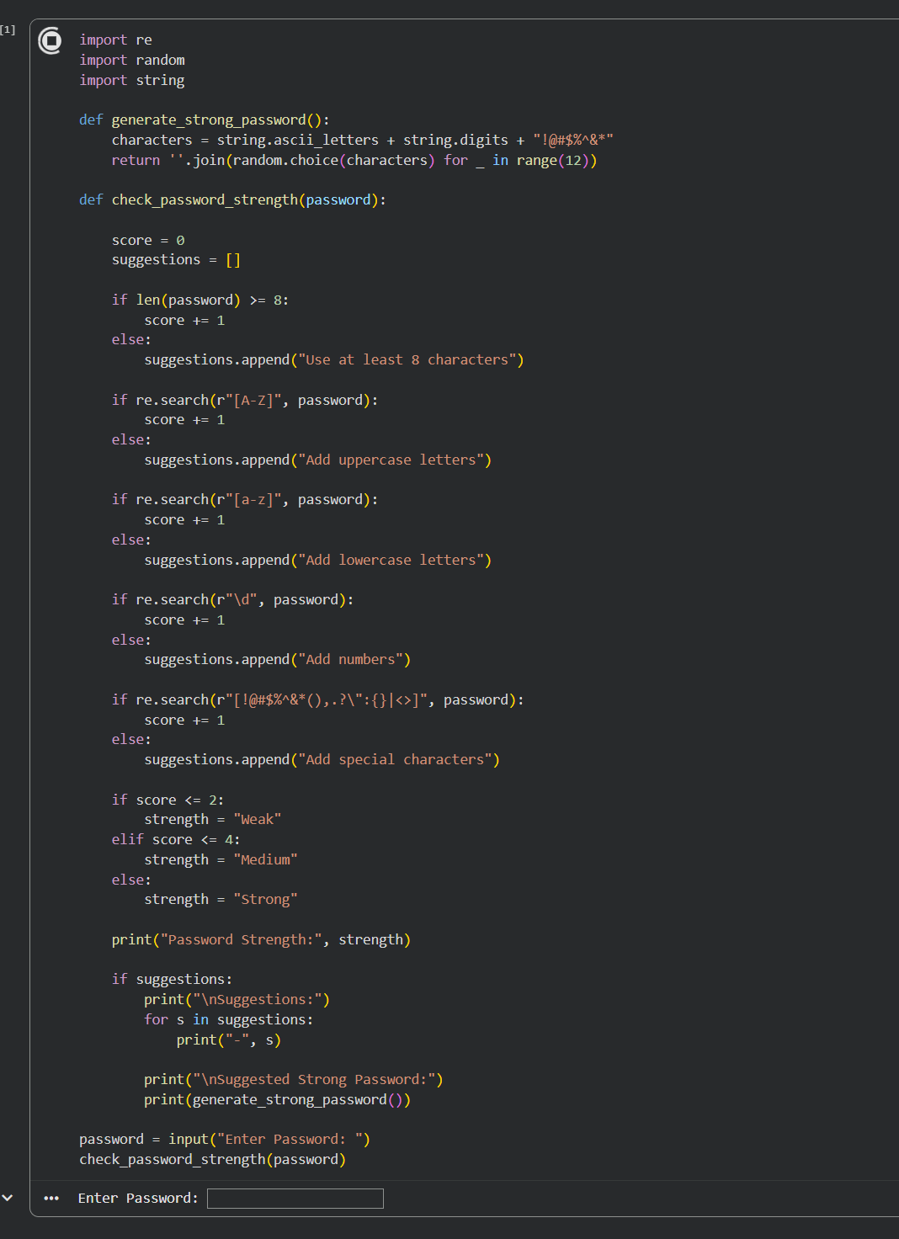

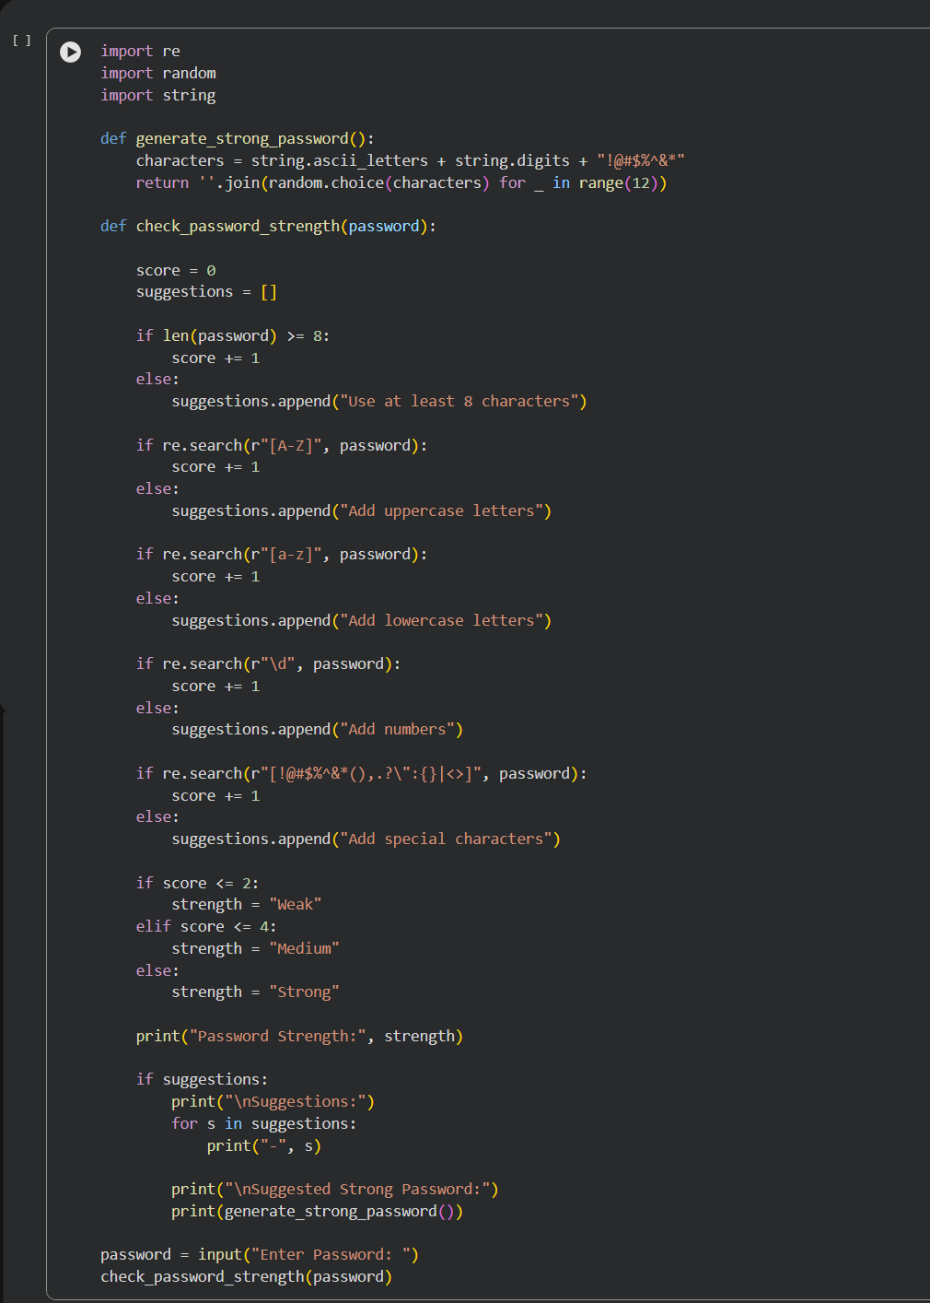

Screenshot 2: Program Execution

Screenshot 3: Weak Password Output

Screenshot 4: Strong Password Output
(Insert Screenshot Here)

SAMPLE OUTPUT
Input:
Password = kani123
Output:
Password Strength: Medium
Suggestions:
- Add uppercase letters
- Add special characters
Suggested Strong Password:
K@9xP#2LmQ7!

ADVANTAGES
- Improves password security awareness.
- Easy to use and understand.
- Provides real-time feedback.
- Encourages strong password creation.
- Reduces risk of unauthorized access.

APPLICATIONS
- User Authentication Systems
- Banking Applications
- Educational Portals
- Social Media Platforms
- Enterprise Security Systems

FUTURE ENHANCEMENTS
- GUI-based interface using Tkinter.
- Password history tracking.
- Database integration.
- Real-time password monitoring.
- Advanced security analysis.

CONCLUSION
The Password Strength Analyzer successfully evaluates user passwords and determines their strength based on multiple security parameters. It provides useful suggestions to improve weak passwords and helps users create stronger credentials. This project demonstrates the importance of password security and basic cybersecurity principles.

REFERENCES
- Python Official Documentation
- Google Colab Documentation
- Cybersecurity Password Guidelines
- Python Regular Expression Documentation

